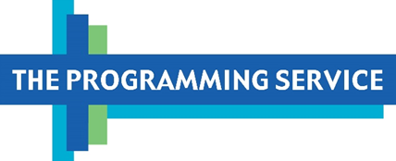

In this edition:
- November brings Crime & Punishment in America and a Miss Scarlet early binge, as well as Native American Heritage and Veterans Day programs.
- December brings new pledge titles and holiday content.
- Don’t miss the suggestions for your carousels in the December section, including one for History from the Other Side of the Pond!

Programming Notes – Digital Edition
October 2026

Passport Activations
We think these shows will murder in Passport and slay activations through November! Let’s kill it with Murder in Sweden season 5 available to stream with Passport on November 13th, Murder in the Mountains season 4 on November 27th and the final season of Miss Scarlet as an early Passport release on November 29th (more about that below). That’s about as much murder as we can handle before we need to curl up with some cider and check under the bed!

Member Messaging
Also, as you prepare for the November/December fundraising drive we wanted to share a great idea to enhance your Passport member messaging– For example, PBS SoCal created a Passport member message to answer viewers' questions about Passport. It’s a wonderful 30-minute filler to go between programs during the drive and might help push Passport memberships and activations. Maybe something to try at your station?

As always, please feel free to copy and paste elements from this newsletter for your local Passport and Digital newsletters. Pass this information to members of your staff who will find it useful.


*NOVEMBER TPS PASSPORT PICK* The Miss Scarlet season 7 early release with Passport on November 29th is a really big deal! Members will have an exclusive chance to view the final season of this viewer favorite! Could we have a better motivator of Passport activations?! Now that we are more than a month out, make sure to get your promotional plan lined up!
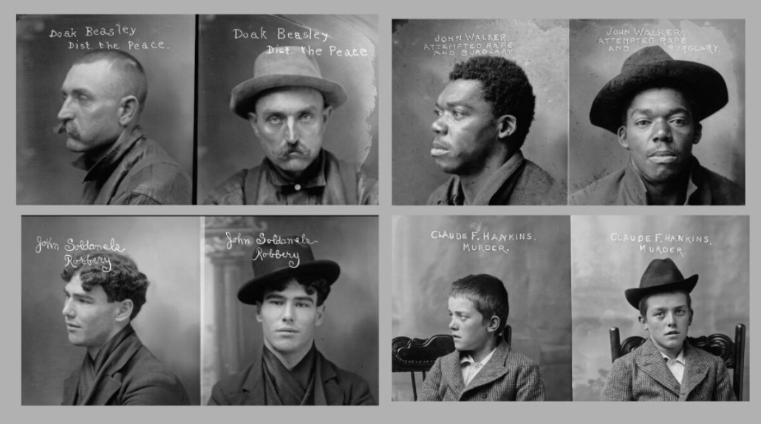
*NOVEMBER TPS FREE STREAMING PICK* The next Florentine Films series, Crime and Punishment in America, will premiere on November 16th, and the full series will be available to stream on FVOD the night of premiere. As we’ve discussed on our monthly calls, this series won’t reach the same streaming totals as American Revolution, but it is an important series that will receive a lot of national promotion.
Programs For Your Featured Shows Row in November

- Pati Jinich Explores PanAmericana s2 – generous 90-day FVOD windows open weekly
- Professor T (UK) s5 – binge with Passport now; 2-week FVOD windows open weekly beginning 10/18
- Maigret on Masterpiece s2 – 2-week FVOD windows open weekly beginning 10/18
- The Gold on Masterpiece s2 – Passport binge available 10/18; 2-week FVOD windows open weekly beginning 10/18
- NOVA “Evolution” – generous 60-day FVOD windows continue open weekly
- Secrets of the Dead – new episodes have 4-week FVOD windows that open with broadcast
- Salute to Service 2026 – 4-week FVOD window opens 11/6
- Medicine Ball – 4-week FVOD window opens 11/9
- Great Performances “Romeo & Juliet” – 4-week FVOD window opens 11/13
- Austin City Limits s52 – generous 3-year FVOD windows open weekly with broadcast; episodes will not be available with Passport following FVOD windows
- Crime and Punishment in America – FVOD binge available 11/16 - 12/14
- Great Performances “Dudamel’s Inaugural Season with the NY Philharmonic” – streaming TBA
- American Masters “Liz Diller and Ric Scofidio: Architect Provocateaurs” – 4-week FVOD window opens 11/24
- Nature “Christmas in the Alps” – 4-week FVOD window opens 11/24
- Paul Simon: The Quiet Celebration Concert – available with Passport beginning 11/26; no FVOD availability
- An Anthem to America: Ken Burns & Florentine Films Celebrate 50 Years – available now with Passport; 4-week FVOD window opens 11/26
- Barbra Streisand: Timeless – Live in Concert – cut down for broadcast; full version available with Passport
PBS Streaming Priorities
- Happiness s1 – Catch-up opportunity on FVOD begins 11/8; season 1 will move back to Passport on 12/6
- Murder in Sweden s5 – Passport binge opens 11/13
- Peace on Earth: Christmas with The Tabernacle Choir – Early FVOD streaming begins 11/26 ahead of the December broadcast premiere
- Murder in the Mountains s4 – Passport binge opens 11/27
- Miss Scarlet s1 – Catch-up opportunity on FVOD begins 11/29; season 1 will move back to Passport on 12/27
- Miss Scarlet s7 - Early Passport binge begins 11/29 ahead of the January broadcast premiere

Plan Ahead for December 2026!

December is bursting with gifts from all genres starting with Lucy Worsley’s Keys to the Castle, holiday content like Peace on Earth: Christmas with the Tabernacle Choir, American Masters: Wilder and Happiness season 2 will also be streaming for those that love this Glee-like drama.

ROYALTY
Lucy Worsley’s Key’s to the Castle will be available to stream with Passport weekly starting December 6th and will also be available as pledge events each week. Lucy Worsley is back with a four-part series that unlocks the doors to four of Europe’s most iconic palaces. With rare access to hidden rooms and private archives, Worsley dives into the art, design, and secret spaces most visitors never see, revealing how these buildings shaped the lives of their royal residents.

BIOGRAPHY
American Masters: Wilder will be available to stream on FVOD starting December 29th for 30 days before moving to Passport. This film is a definitive documentary on Gene Wilder's life and legacy, exploring his work as an actor, writer, and creative force behind some of the most beloved films of the 20th century. Featuring rare archival footage, personal interviews, and insights from collaborators, the film offers a revealing portrait of Wilder's career and personal journey.
PERFORMANCE
Peace on Earth: Christmas with the Tabernacle Choir will be an early streaming opportunity in Passport on Thanksgiving Day but will hit broadcast schedules on December 14th which may give it a bump. The Tabernacle Choir and Orchestra at Temple Square join with Tony Award winner Stephanie J. Block and star of stage and screen Sebastian Arcelus for this timely Christmas special. Filmed before a live audience at the Conference Center in Salt Lake City, “PEACE ON EARTH” offers a wide range of popular and classical Christmas music selections along with a true story of Christmas from the Apollo 8 mission to the moon, 1968.
DRAMA
Happiness season 2 will be available to stream with Passport on December 13th. Season 2 of this musical series sees director Charlie Summers well and truly cancelled on Broadway. In despair, and eating far too many lamingtons, he’s vowing never to work in theatre again. That is until mum, Gaye, talks him into directing amateur theatre group Pizazz’s new show. He just can’t help himself.
See suggestions for your carousels on the next page. We are refreshing carousels monthly and adding some new ones to give you options for your show rows. Hope this is helpful!

Suggestions for your Carousels
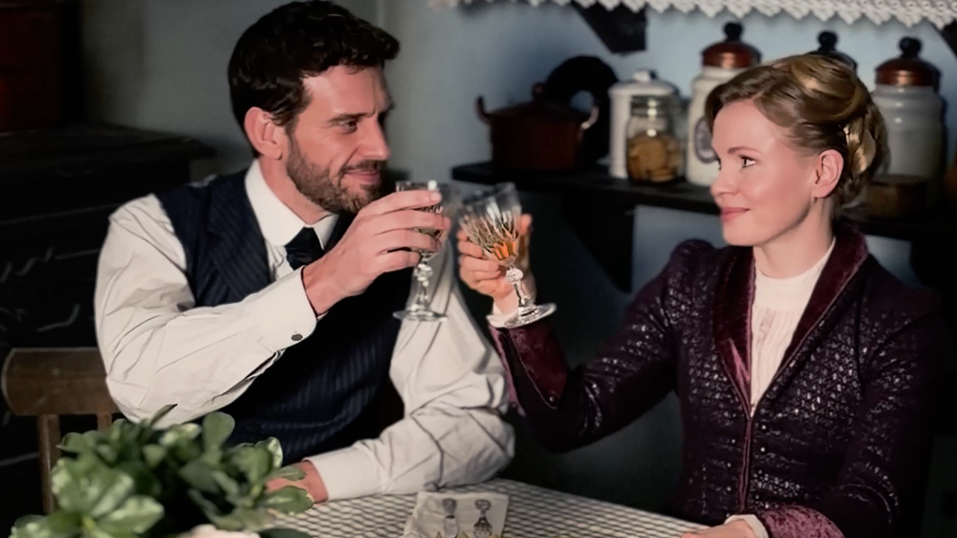
With the final season of Miss Scarlet (season 7) around the corner, we think this is a great time to put on your top hat, squeeze into that corset and swoon a little.

Top Hats, Corsets and Romance
Dramas that take you back in time


- All Creatures Great and Small on Masterpiece (seasons 1 - 6)
- The Count of Monte Cristo on Masterpiece (episodes 5620 - 5627)
- Miss Scarlet on Masterpiece * (seasons 1 – 7; season 7 releases 11/29)
- The Forsytes on Masterpiece (season 1)
- Poldark on Masterpiece (seasons 1 - 5)
- Downton Abbey (seasons 1 - 6)
- Velvet (seasons 1 - 4)
- Paradise * (seasons 1 – 13; s13 releases 12/4)
- Sanditon on Masterpiece (seasons 1 - 3)
- Seaside Hotel (seasons 1 - 10)
- Wolf Hall on Masterpiece (seasons 1 - 2)



Lucy Worsley has become a public media darling and delivers one series after another that makes our anglophiles and history buffs happy. So, we think this new series is a great opportunity to offer a row of all that wonderful content from across the pond that our audience flocks to.

History from the Other Side of the Pond
Stories to bring the past to life
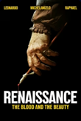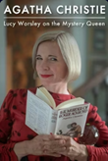

Lucy Worsley's Keys to the Castle *
- Lucy Worsley Investigates
- Renaissance: The Blood and the Beauty
- Leonardo Da Vinci
- Lucy Worsley’s Royal Myths & Secrets
- Agatha Christie: Lucy Worsley on the Mystery Queen
- Lucy Worsley’s Holmes vs. Doyle
- The Boleyns: A Scandalous Family
- Lucy Worsley’s Royal Palace Secrets
- Inside the Court of Henry VIII



There is so much to love from PBS during the holidays, including the new Peace on Earth: Christmas with the Tabernacle Choir and new pledge event A Celebration of Hanukkah. Take a look at the curation list below which will not disappoint! May the holidays shine a little brighter this year!
Happy Holidays
Programs that make the holiday season shine a little brighter
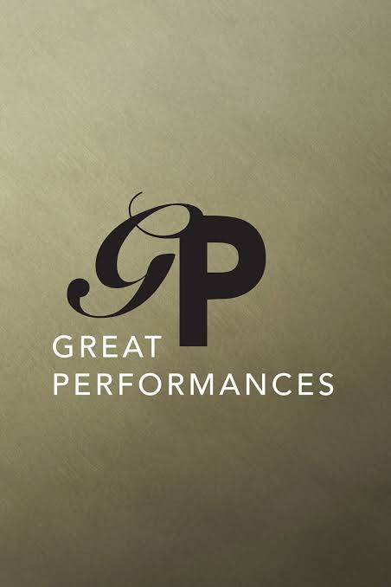
Peace On Earth: Christmas with the Tabernacle Choir *
A Celebration of Hanukkah * (new pledge event; streaming details TBA)
- All Creatures Great and Small on Masterpiece
  - Comfort & Joy (episode 5613)
  - All God’s Creatures (episode 5513)
  - The Night Before Christmas (episode 5108)
  - The Perfect Christmas (episode 5215)
  - Merry Bloody Christmas (episode 5313)
  - On a Wing and a Prayer (episode 5413)
- Christmas With the Tabernacle Choir
  - Hope of the Season: Christmas with the Tabernacle Choir
  - Joy: Christmas With the Tabernacle Choir
  - Season of Light: Christmas with the Tabernacle Choir
  - O Holy Night: Christmas with the Tabernacle Choir
- Great Performances: Nutcracker from English National Ballet (episode 5116)
- Mary Berry's Highland Christmas
- The St. Olaf Christmas Festival: Our Hope for Years to Come
- Too Hot to Handel: The Gospel Messiah
- Mary Berry’s Ultimate Christmas
- American Masters: Brenda Lee: Rockin’ Around (episode 3703)
- All is Calm: The Christmas Truce of 1914 (expires 12/15/26)
- Nature: Christmas at Yellowstone (episode 2403)
- A Chef’s Life Holiday Special
- Craft in America: Holiday (episode 502)
- Craft in America: Celebration (episode 702)
- How She Rolls: A Very Carrie Christmas (episode 210)

BaBette, Justin, Cyndy, Bryant, Alexis, Andrea, Jessica, Kayla & Sabrena

To help you answer viewer questions, here are Walter Presents titles that will be added to Passport soon. You can see the full list of new 2026 Walter Presents titles here.

Available 10/23/2026

Classified, Season 2 (10x60)
Rachel tries to free two Canadian citizens detained in the Maghreb. At the same time, she is ordered to capture a French mercenary in Montreal for unknown reasons. In French with English subtitles. Expiration: 6/30/29

Available 10/30/2026

Belcanto, Season 1 (8x60)
Description: TBD
Expiration: 12/31/29

Available 11/6/2026

Single Bells, Season 1 (12x30)
Amidst a flurry of first dates, a secret admirer catches Mina’s attention with his thoughtful gifts. However, as her family battles their own issues in the lead-up to Christmas, Mina wonders if she will ever find “the one.” In Flemish with English subtitles. Expiration: 1/31/30

Available 11/13/2026

Murder in Sweden, Season 5 (8x60)
Description: TBD
Expiration: 8/31/29

View this document for a list of programs now available on Passport in Canada. As more information becomes available, the document will be updated. Information may be subject to change.

